# C3- S2 - PRACTICE

**EXERCISE 1:**

[**Databases on W3School**](https://www.w3schools.com/sql/trysql.asp?filename=trysql_select_all)

1. **Selecting**

Write statements to extract data from all tables from w3shool order at least one column by ASC and other one by DESC.

1. **Customers** : select * from customers order by customername DESC;

select * from customers order by country ASC;

1. **Categories :** select * from Categories order by CategorieName DESC.

select * from customers order by country ASC;

1. **Employees :** select * from Employees order by CategorieName DESC.

select * from Employees order by country ASC;

1. **OrderDetails:** select * from OrderDetails order by CategorieName DESC.

select * from OrderDetails order by country ASC;

1. **Orders :** select * from Orders order by CategorieName DESC.

select * from Orders order by country ASC;

1. **Products :** select * from Products order by CategorieName DESC.

select * from Products order by country ASC;

1. **Shippers :** select * from Shippers order by CategorieName DESC.

select * from Shippers order by country ASC

1. **Suppliers :** select * from Suppliers order by CategorieName DESC.

select * from Suppliers order by country ASC

1. **Where clause** 
   1. Write a statement to extract all data from products where the price equals 19.5.

SELECT * FROM Products WHERE Price = 19.5;

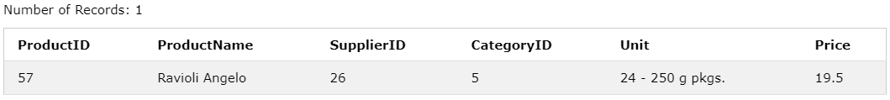

* 1. Write a statement to extract all data from orderDetail where the Quantity is greater than 10.

SELECT * FROM orderDetails WHERE Quantity > 10;

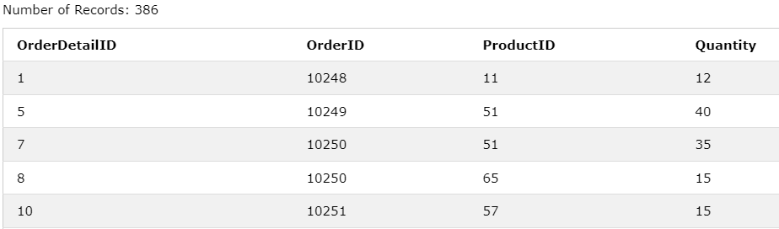

* 1. Write a statement to extract all data from shippers where the shipperid less than 3.

SELECT * FROM Shippers WHERE shipperid < 3 ;

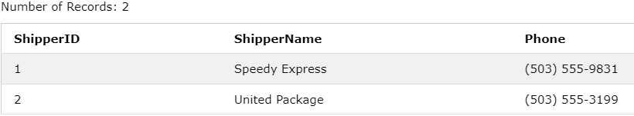

* 1. Write a statement to extract all data from products where the price is Greater than or equal to 40.

SELECT * FROM Products WHERE price >= 40;

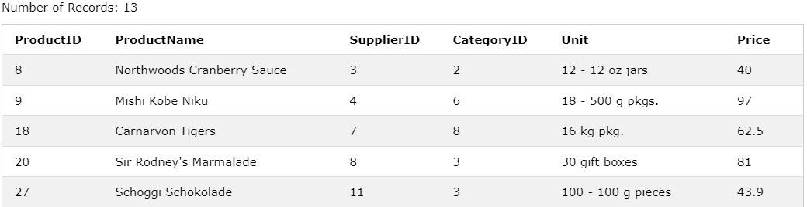

* 1. Write a statement to extract all data from products where SupplierID is Less than or equal to 9.

SELECT * FROM Products WHERE SupplierID =< 9;

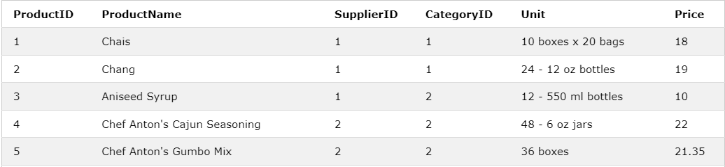

* 1. Write a statement to extract all data from customers except “Canada”.

SELECT * FROM customers WHERE NOT Country = ‘Canada’ ;

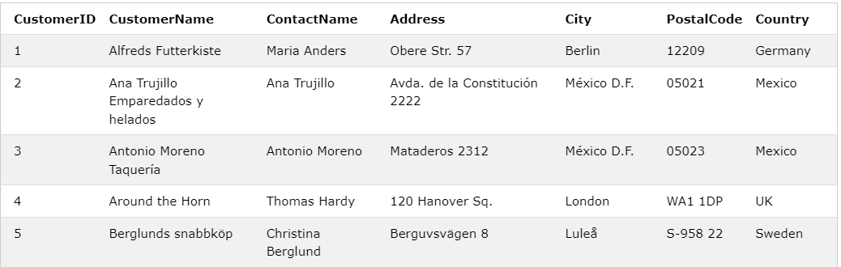

* 1. Write a statement to extract all data from products where the price is between 10 to 30.

SELECT * FROM Products WHERE Price Between 10 and 30 ;

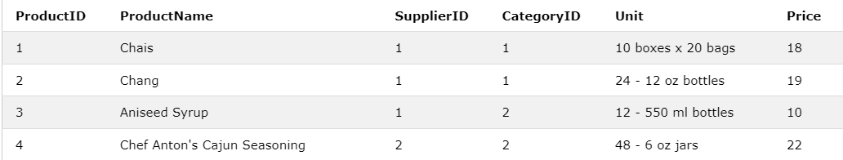

* 1. Write a statement to extract all data from customers where the customername starts with letter O.

SELECT * FROM Customers WHERE customername LIKE ‘S%’ ;

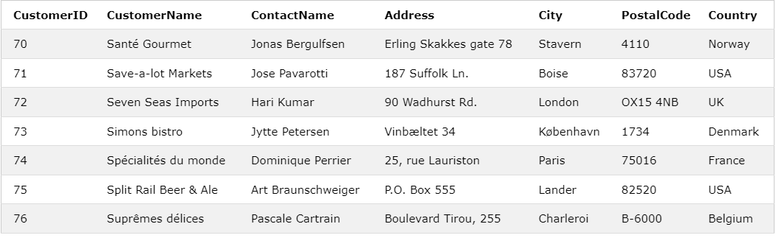

* 1. Write a statement to extract all data from suppliers where the country is in “USA, Italy, France”

SELECT * FROM suppliers WHERE Country in (‘USE’, ‘Italy’, ‘France’) ;

